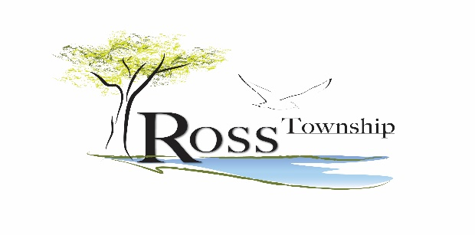
12086 M-89
Richland, MI 49083
269-731-4888

SNAG A SUMMER JOB ON GULL LAKE!
Ross Township Park Attendants
Ross Township is now accepting applications for Ross Township Park Attendants. The park opens around Memorial Day and closes around Labor Day (depending on weather forecasts)
Applicants are expected to be reliable, punctual, honest, and be a team player. Park Attendants ensure a High-Quality Appearance of Ross Township Park and a smooth and friendly operation for all guests enjoying Ross Township Park.
$14.00 per hour
COMMITMENT MINIMUM 20 hours scheduled per week, including weekends
LIMITED POSITIONS AVAILABLE!
APPLY TODAY!
PAID TRAINING!
To apply, fill out application and return it at Ross Township offices:
12086 M-89 Richland, MI 49083.

Applications will be accepted through May 13, 2022.

